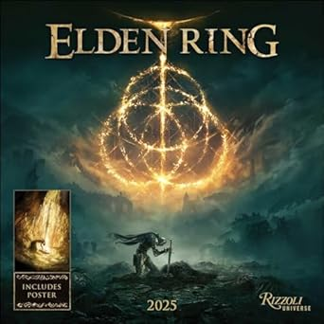

*Elden Ring:*

**1️. Vast Open-World Exploration**

Set in the **Lands Between**, featuring **diverse landscapes, hidden dungeons, and secret locations**, with **horseback traversal (Torrent)**.

**2️. Deep & Customizable Combat**

Offers **multiple playstyles** with **melee, ranged, magic, and Ashes of War** to modify weapons and abilities.

**3️. Challenging & Epic Boss Battles**

Includes **difficult, large-scale boss fights** like **Malenia, Radahn, and Morgott**, each with unique attack patterns.

**4️. Rich Story & Lore by George R.R. Martin**

Features a **deep, mysterious narrative**, revealed through **NPCs, cryptic item descriptions, and environmental storytelling**.

**5️. Award-Winning & Highly Acclaimed**

Won **Game of the Year (2022)** and sold over **23 million copies**, making it one of the most successful **Soulslike RPGs**.